**Order your 2025 Glacial Lakes Travel Guides today!**



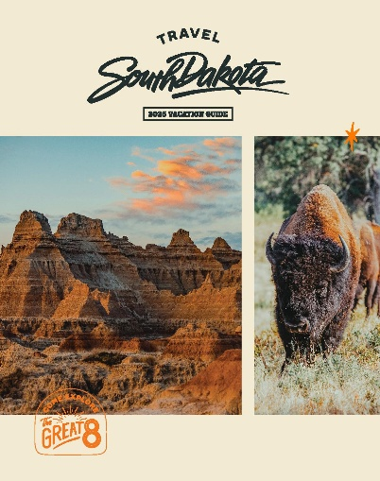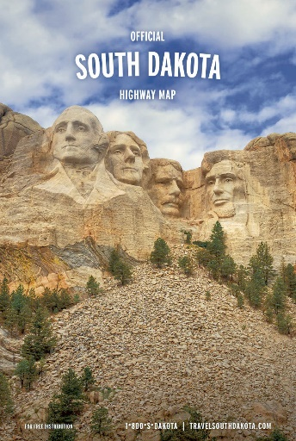

**(SD State Maps – 240/box)**

**(SD Vacation Guides – 15/box)**

**(Regional Guides – 75/box)**

**Please send us __ ___ copies of the Glacial Lakes & Prairies Travel Guide**

**Please send us __ ___ copies of the South Dakota Vacation Guide  
Please send us _ ___ copies of the SD State Map**

**Business/Organization Name:__**Click or tap here to enter text.**______  
Physical Address:___**Click or tap here to enter text.**_______________  
City:__**Click or tap here to enter text.**___State:_**Click or tap here to enter text.**__Zip:__ ___  
Contact Person:__**Click or tap here to enter text.**___Phone:__**Click or tap here to enter text.**__  
E-mail:_**Click or tap here to enter text.**_________**

**To order/re-order guides, please e-mail Jody Williamson at**[**Jody@sdglaciallakes.com**](mailto:Jody@sdglaciallakes.com) **or call (605) 886-7305.**

